

Assignment 2: RMIT E-Commerce Store

Students | Tran Quoc Hung – S4027060
 | Luong Thi Tra My - S3987023
 | Le Tuan Hung - S4069761
 | Nguyen Viet Son – S4052257
 | Nguyen Nguyen Hai - S3978275
 | Bui Thai Son - S4037172
Course | System Deployment and Operations
Course Code | COSC2767
Lecturer's Name | Tom Huynh, Dung Nguyen
Submission Date | 19 Sep 2025

Formal Declaration: We hereby declare that in submitting all work for this assessment we have read, understood and agreed to the content and expectations of the Assessment declaration.

TABLE OF CONTENTS
- CI/CD Pipeline Solution 3
  - Problem Statement 3
  - Proposed Solution 3
    - Tools and Technologies: 4
    - Pipeline Features 6
- Main Requirements 8
  - Cloud integration 8
  - Containerized Microservice 8
  - Automated CD/CI pipeline: G
2.8 Automated Alerting System 11
- Advanced Requirements 14
  - Infrastructure as Code 14
  - Blue-Green Deployment Strategy 15
  - Additional Enhancements 15
- Application Flow 16
- Known Issues 18
- Self-Evaluation and Reflections 19
- Project Responsibilities 20
- Conclusions 21
- Apenddix 22
- References 7

CI/CD Pipeline Solution

Problem Statement
In modern software development, continuous delivery and system reliability are paramount to user satisfaction and operational stability. The rapidly expanding RMIT E-commerce store necessitates frequent updates to adapt to evolving market demands, presenting significant challenges for both business and software development teams. Currently, the platform relies on manual deployment and maintenance processes utilizing the MERN stack (MongoDB, Express.js, React, and Node.js). This approach introduces several key challenges, including a heightened risk of human error during deployments, inconsistent quality due to limited test automation, difficulty in version control and change tracking, scalability limitations, inefficient rollback procedures, and hindered team collaboration. These issues increased pressure on the developer team, significantly impacted the web developer workflow, Tom, and posed a threat to the long-term success of the RMIT E-commerce Store.
To effectively address these challenges, this project proposes implementing an industry-standard Continuous Integration/Continuous This robust CI/CD framework will automate deployment processes and testing protocols to minimize errors, enhance deployment visibility through comprehensive notification systems, support scalable solutions with cloud services and containerization technologies, facilitate secure rollbacks and advanced deployment strategies, and promote team collaboration via GitHub integration. By adopting this pipeline, the project aims to address Tom's current challenges, incorporate industry best practices, and ensure that the RMIT E-commerce Store operates efficiently, reliably, and resiliently while maintaining scalability.

Proposed Solution
A bottleneck in the delivery of updates and new features is significantly hindering the RMIT E-commerce Store’s ability to respond to customer needs and maintain a competitive

edge. The current manual deployment process is time-consuming, prone to errors, and lacks the scalability required to support the store’s growing traffic and complexity. This results in delayed releases, increased risk of downtime, and a frustrated development team. Therefore, bellow solution is developed to address these challenges by implementing a robust and automated CI/CD pipeline, empowering the RMIT E-commerce Store developer to deliver updates and new features efficiently and reliably.
This solution proposes implementing a comprehensive CI/CD pipeline leveraging AWS services to automate the build, testing, and deployment of updates to the RMIT Store. The pipeline will address the existing challenges by automating repetitive tasks, improving code quality, and enabling faster, more reliable releases. The pipeline will consist of the following stages:

Tools and Technologies:
This solution utilizes the following tools and technologies to create a robust and efficient CI/CD pipeline:
      - Amazon Application Load Balancer (ALB): Distributes incoming traffic across multiple EC2 instances hosting the RMIT Store application for balanced load handling and optimal resource utilization. CloudWatch monitors the entire infrastructure pipeline, collecting and analyzing metrics, logs, and events from ALB, EC2 instances, and applications to ensure smooth operation and performance. CloudWatch tracks request count, latency, and error rates for ALB, maintaining high availability and responsiveness, and triggers SNS notifications for issues like elevated CPU utilization or unhealthy hosts [1].
      - Amazon CloudFormation: Utilized as Infrastructure as Code (IaC) to define and provision necessary AWS resources (EC2 instances, ALBs, CloudWatch alarms) in a repeatable and automated manner. Uses YAML files for defining infrastructure components, ensuring version control and auditability [2].

      - Amazon Elastic Container Registry (ECR) AWS-managed service providing a secure, scalable, and reliable container image registry. It supports private repositories with AWS IAM permissions for user or EC2 instance access. Users can push, pull, and manage Docker and Open Container Initiative (OCI) images using their preferred CLI tools [3].
      - Amazon SNS (Simple Notification Service): Integrated to deliver real-time notifications to the development team for critical events such as failed builds, failing tests, or unhealthy infrastructure components, with notifications sent via email for prompt response [4].
      - Amazon EC2 Instances: secure, scalable compute capacity compute environment for hosting Jenkins and the RMIT Store application [5]. Also, this instance managed by AWS CloudWatch for monitors CPU, network, and disk metrics to ensure stability and performance [6].
      - Jenkins: Jenkins, a prominent open-source automation server, provides a comprehensive suite of plugins for developers to orchestrate project lifecycle management, including building, deployment, and automation. It monitors version control repositories for code changes, triggers builds, executes tests, constructs images, and deploys applications [7].
      - Ansible: Ansible is an open-source IT automation tool enabling system configuration, software deployment, and advanced workflow orchestration to support tasks like application deployment and system updates. Known for its simplicity and user-friendliness, Ansible focuses on security and reliability with minimal components. It leverages Secure Shell connection for transport (with additional options available), employing a straightforward language that facilitates quick adoption without extensive training [8].
      - Docker and Docker Swarm: Facilitates containerization for horizontal scaling of the RMIT Store across multiple nodes. Docker ensures consistency and portability across environments, while Swarm enables automated load balancing, service discovery, and resource management for high scalability and reliability. Docker

images are stored on Amazon Elastic Container Registry for sharing and version control. IaC practices further enhance manageability and reproducibility [9] [10].

Pipeline Features
The proposed pipeline integrates multiple DevOps practices to ensure continuous, reliable and scalable software delivery. Its main features include:
      - Automated Continuous Integration (CI): Automatically fetches source code changes from a private Github repository, triggering Jenkins builds upon each push. These builds encompass code compilation, dependency management, and comprehensive unit/integration testing to proactively identify errors. Email notifications are integrated to provide the development and DevOps teams with immediate feedback on build status, test results, and any failures, accelerating iteration and issue resolution.
      - Containerization for Consistency: Packages all application components (frontend, backend, database) into separate Docker containers, encapsulating dependencies and runtime configurations. This ensures consistent execution across development, testing, and production environments, promoting portability and eliminating "works on my machine" issues. Multiple services run as independent containers, enhancing modularity and maintainability.
      - Orchestration with Docker Swarm: Manages container deployment and scaling across multiple nodes using Docker Swarm. Supports service replication for high availability in case of node failures and utilizes load balancing to enhance performance and reliability.
      - Ease of Server Configuration & Management with Ansible: Incorporates automated server configuration and management through Ansible playbooks integrated into the pipeline. This guarantees consistent infrastructure provisioning, dependency installation, and service configuration across all environments, reducing human error and manual overhead. Infrastructure is treated as code for reliable replication of any server (staging, production).

      - Scalability & High Availability with Elastic Load Balancing: Ensures continuous application access without downtime using an Elastic Load Balancer (ELB) which distributes incoming traffic across multiple nodes in the Swarm cluster. ELB routes traffic only to healthy instances and reroutes requests if instances become unavailable, enhancing fault tolerance and system resilience.
      - Continuous Delivery with Staging & Production Environments: Updates are automatically deployed to a staging server for initial testing. Passing tests enable promotion to production, either automatically or with manual approval. Failures trigger email alerts to the DevOps team for immediate resolution, reducing inconsistencies and validating requirements before live release.
      - Automated Continuous Deployment (CD): Once builds pass all tests in the testing environment, Jenkins automatically pushes the Docker image to a container registry and deploys it to the Swarm cluster, minimizing manual intervention and enabling faster, more reliable releases.
      - Rollback Capability: Previous stable Docker images are securely stored in the AWS container registry, enabling rapid reversion to earlier versions in case of deployment failures, minimizing downtime and mitigating risks during production rollouts.
      - Monitoring & Logging Support: (Implied through alerting and testing - can expand if more details are available on the specific tools used) Leverages integrated testing and alerting to provide insights into application health and performance.
      - Security Integration: Securely manages credentials and secrets within Jenkins to protect sensitive data like registry credentials and API keys. Source code and configuration files are stored in a private Github repository, and secure connections are established between services, nodes, and containers utilizing credentials or security groups.

Main Requirements

Cloud integration
The proposed solution heavily leverages the comprehensive suite of Amazon Web Services (AWS), deploying dedicated EC2 instances to support both service operations and development activities (Figure 1). The project team utilizes cost-effective t3.small instances for worker, master, and developer nodes, balancing affordability with functionality. This setup provides a robust yet economical solution for workload management. This design aims to enhance and scale the infrastructure of the RMIT Store project by utilizing AWS offerings such as EC2, CloudFormation, ECR, CloudWatch, and Application Load Balancer (ALB). By adopting this architecture, the environment achieves scalability, reliability, and operational efficiency. CloudWatch is integral to this framework, providing advanced monitoring and alerting to maintain system performance. Alarms like RmitStoreJenkinsHighCpu and RmitStoreAlbUnhealthyHosts are deployed to proactively detect potential performance issues and service interruptions, with predefined thresholds for CPU usage and host health that ensure infrastructure resilience under fluctuating workloads (Figure 2). Also, regarding Figure 3 the Application Load Balancer further optimizes resource allocation by distributing traffic efficiently and performing health checks, thereby routing requests exclusively to healthy endpoints. Together, these AWS services form a cohesive ecosystem that promotes optimal resource utilization and supports sustained growth and adaptability. This solution establishes a robust foundation for further refinement of infrastructure configuration and adherence to cloud architecture best practices.

Containerized Microservice
This deployment leverages a containerized microservices architecture, isolating each application component—frontend, backend, and database—into dedicated Docker

containers to promote modularity, scalability, and consistent operations across environments. Dedicated Dockerfiles are maintained within both the client and server directories to streamline local development and testing processes. For production workloads, orchestration is managed using Docker Swarm. Each service is deployed with defined placement constraints: the frontend (React application) operates on nodes labeled 'frontend,' the backend (API service) is assigned to 'backend' nodes, and the MongoDB database container running on the official MongoDB image container. Distributing these services across separate physical servers enhances reliability through fault isolation and supports independent scaling of individual components. Docker images are for these services are successfully built and stored in Amazon Elastic Container Registry (ECR), referenced as rmit-store-backend and rmit-store-frontend (Figure 4). These images are then stored in environment variables and used in prod-green-stack.yml, prod-stack.yml, and staging-stack.yml, enabling efficient deployment, rollout, and rollback procedures.

Automated CD/CI pipeline:
The purposed pipeline supports both manual and automated triggering. Given the resource constraints of the AWS Learner Lab environment – specifically limited budget which result in limit access to public domains and dynamic IP addresses – we have implemented automated triggering via Jenkins’ Poll SCM functionality. (Figure 5) A polling interval of five minutes strikes a balance between responsiveness and operational stability, ensuring timely build initiation upon detection of changes within the designated repository. This also enables rollback feature base on GitHub commits. For production deployments, we recommend highly recommended the webhook-based pipeline triggers for better experience, leveraging services like AWS Route 53 or similar DNS solutions to enhance reliability and efficiency.
The pipeline automates the process of building, testing, and deploying application code changes. Updates are initially deployed to a dedicated staging environment where rigorous testing is performed. Successful completion of these tests triggers an automated deployment to production utilizing a Blue-Green deployment strategy. This strategy

involves deploying a new version alongside the existing live version, switching traffic, and removing the old version upon successful verification. The entire process is driven by Infrastructure as Code (Jenkinsfile), ensuring repeatability and consistency. Twelve steps of CD/CI pipelines (Figure 6) can be access through the port 8080 of from RmitStoreJenkinManagerDB instance and can be consecutive described as bellow:
- Checkout: Pulls source code from the repository every 5 minutes and sets up the workspace.
- Setup AWS Environment: Configures AWS credentials, sets ECR repository URLs, finds ALB DNS name, and sets image tags.
- Update SSM Parameters: Creates/updates AWS Systems Manager Parameter Store values for ALB DNS in staging and production.
- Server Unit Tests: Runs server unit tests (Node.js backend) and performs syntax, package, dependency, main file load, and optional test script execution.
- Client Build Tests: Installs frontend dependencies, builds the project, and verifies build outputs, HTML structure, assets, sizes, and the configuration
- Build & Push Images - Builds Docker images for frontend and backend and pushes them to Amazon ECR.
- Configure Worker ECR Access - Configures Docker Swarm worker nodes with ECR login credentials for image pulling.
- Cleanup & Configure Worker Nodes: Connects to Swarm worker nodes via SSH, purges Docker resources, confirms AWS credentials, and logs into ECR for image retrieval.
- Label Swarm Nodes: Assigns role labels to Docker Swarm nodes for service placement constraints (e.g., frontend, backend, manager).
- Deploy to Staging (Swarm): Deploys the application stack to the staging environment using Docker Swarm.
- Seed Staging Database: Executes an Ansible playbook using dynamic inventory to populate MongoDB with initial data in the staging setup.

- Integration Tests (API): Conducts health checks, endpoint availability tests, JSON format validation, latency measurement, and light concurrency testing on the staging backend API.
- UI Tests (Frontend): Checks frontend accessibility, verifies HTML and asset presence, tests routing functionality, and measures response times against the staging environment.
- Blue Green to Production Implements - Deploys a new version of the stack on different ports, performs health checks, temporarily modifies ALB target groups for promotion or rollback.

2.8 Automated Alerting System:
An automated alerting system integrated with Jenkins sends email notifications to the development team for any build, test, or deployment failures. The project’s alerting infrastructure utilizes AWS services to provide timely notifications regarding pipeline failures and operational health issues. A central component is the monitoring.yaml configuration file, which defines an SNS Topic named “RmitStoreAlerts” and an associated subscription email. This subscription ensures that all messages published to the topic are delivered to the designated team email address (Figure 8). Notably, this same SNS Topic serves as a unified endpoint for various CloudWatch alarms monitoring critical infrastructure components such as Application Load Balancers (ALBs) and Jenkins server resource utilization. By centralizing alerts through this mechanism, a consistent notification process is maintained irrespective of the alert source. A detailed failure message is subsequently constructed, including relevant build metadata such as the build number, branch name, commit hash, and Jenkins job number. This structured notification is then published to the SNS Topic via the AWS SNS publish command with a clear subject line indicating a pipeline failure. The overall flow ensures that both CI/CD pipeline failures and operational alerts triggered by CloudWatch alarms are consistently routed through the “RmitStoreAlerts” SNS Topic, ultimately reaching the team inbox via email subscription.

2.5 Automate testing Framework:
To ensure successful deployment and maintain the integrity of the RMIT store, this CD/CI pipeline incorporates a custom testing framework designed for speed, resource efficiency, and robust regression protection. The framework minimizes dependencies while safeguarding against common issues such as syntax errors, missing files, build failures, and broken endpoints. Successful completion of all tests (Figure 9) allows the pipeline to proceed; otherwise, execution is suspended, and the development team is immediately notified thorough the SNS Notification Services for further action and preventing other potential failures from impacting other RMIT store processes.
This automated CD/CI pipeline uses a layered testing approach to ensure functionality, reliability, and rapid feedback. It prioritizes “shift-left” practices like syntax and load checks to reduce build time. Build validation confirms artifact integrity. Post-deployment, API integration tests verify the runtime environment, including container orchestration, port configurations, ALB path rules, and SSM configurations. Finally, Frontend UI smoke tests confirm end-user accessibility. Each layer is fault-tolerant, using warnings for non-critical issues to maintain pipeline resilience during infrastructure propagation delays. Key testing stages and mechanisms include:
- Server Unit Tests: Focus on backend code integrity with fast feedback - dependency installation (npm ci), syntax scanning, structural validation, and a lightweight main file load test (Figure 1 Apendix).
- Client Build Tests: Validates the frontend build process via npm ci and npm run build, verifying the presence of deployable assets, essential package.json fields, and basic HTML structure.
- API Integration Tests: Confirms deployed backend service behavior within the staging environment by probing health endpoints, validating JSON responses, and assessing endpoint reachability and latency.

- Frontend UI Smoke Tests: Checks user-facing page deployment via the ALB, inspecting HTML structure, verifying asset loading, and assessing page latency and routing behavior.

2.9 Orchestration
Docker Swarm facilitates the deployment, scaling, and management of containerized applications through coordinated orchestration. Operating in swarm mode on the designated manager node, Docker Swarm utilizes stack files to define service configurations for applications. During the Jenkins pipeline, the "Deploy to Staging (Swarm)" stage leverages Docker Swarm to deploy the application stack directly into the staging environment, ensuring that deployment processes are automated, reliable, and consistent. This approach aligns with the overall CI/CD workflow and supports efficient environment management, with distinct configurations for different environments: frontend services on ports 80 (prod), 81 (staging/blue), and 82 (green); backend services on ports 3000 (prod), 3001 (staging/blue), and 3002 (green); alongside supporting services such as MongoDB on port 27017, a custom discovery service on 9999, and Docker Swarm's internal communications over ports 2377, 7946, and 4789.
The main containers in the Docker Swarm deployment include frontend services utilizing React builds with static hosting, employing a multi-stage build process. The build stage utilizes node:22-alpine, while the runtime stage leverages nginx:alpine for serving compiled assets, resulting in smaller, faster deployments with efficient static file caching and enhanced security through non-root user operation and reduced attack surface. For the backend services, the project team ultilize node:22-alpine to host APIs built with Express/Node, where the Alpine base minimizes size, health checks ensure reliability, and a non-root user configuration enhances security. The database is deployed as a service within the Swarm stack using official MongoDB images specified in deployment stack files referenced in Jenkins pipelines. This setup supports multi-stage builds only where beneficial, promotes separation of concerns with Nginx for static delivery and Node for

APIs to improve caching and scaling, ensures consistent node versions across build and runtime environments to avoid dependency mismatches, and integrates health checks to support Swarm readiness and load balancing.

Advanced Requirements

Infrastructure as Code
Regarding Figure 10, AWS CloudFormation is utilized to define and provision the application infrastructure, encompassing EC2 instances, security groups, load balancers, and auto-scaling groups. Infrastructure as Code (IaC) is implemented through modular CloudFormation templates within the infra directory, enabling independent deployment and management of components:
- rmit-network-stack (network.yaml): Establishes the foundational networking layer with VPC, subnets, internet gateway, and security groups
- rmit-ecr-stack (ecr.yaml): Creates Elastic Container Registry repositories for Docker image storage
- rmit-compute-stack (compute.yaml): Provisions EC2 instances for Jenkins manager/database and worker nodes with automated Docker Swarm configuration
- rmit-alb-stack (alb.yaml): Deploys Application Load Balancer with target groups for frontend and backend service routing
- rmit-ssm-staging-stack and rmit-ssm-prod-stack (ssm.yaml): Manages AWS Systems Manager Parameter Store for environment-specific configuration secrets
- rmit-monitoring-stack (monitoring.yaml): Implements CloudWatch monitoring, alerting, and SNS notifications for system observability
This modular approach, combined with automated UserData scripts for Docker, Jenkins, and swarm initialization, streamlines resource provisioning and eliminates manual configuration. The Infrastructure as Code - IaC framework supports a complete CI/CD

pipeline orchestrated by a Jenkinsfile, demonstrating consistent, repeatable, and version-controlled infrastructure management for seamless deployment and scalability.

2 Blue-Green Deployment Strategy
A blue-green deployment strategy is implemented to minimize downtime and mitigate risks associated with software deployments. This approach involves deploying a new version of the application (GREEN) alongside the currently active version (BLUE). Once the GREEN environment has been successfully verified through comprehensive health checks, traffic is seamlessly rerouted from BLUE to GREEN.
The configuration for this advanced deployment strategy includes a Jenkinsfile that outlines stages for deploying both BLUE and GREEN environments, ALB rules configured to direct traffic to the appropriate target group based on the environment status, and thorough health checks ensuring the readiness of the GREEN environment prior to switching traffic. The ports used for the Blue-Green Deployment are: Blue Deployment: Standard ports 80 (frontend) and 3000 (backend). Green Deployment: Preview ports 82 (frontend) and 3002 (backend). These ports are defined in multiple files, such as: Frontend Green: Port 82 in prod-green-stack.yml and alb.yaml. Backend Green: Port 3002 in prod-green-stack.yml and alb.yaml. Proofs encompass Jenkins pipeline logs illustrating the blue-green deployment process, screenshots detailing ALB target group configurations, and logs reflecting health check outcomes. The justification for this strategy centers around its ability to ensure zero downtime while providing a straightforward rollback mechanism in case issues are detected.

Additional Enhancements
The CI/CD pipeline has undergone several enhancements aimed at bolstering security, reliability, and user experience. One key improvement involves the secure management of environment variables through AWS SSM Parameter Store. This tool safely stores critical configuration details such as CLIENT_URL, JWT_SECRET, and BASE_API_URL, ensuring that sensitive information is protected from unauthorized access while

maintaining seamless operations within development and production environments. In addition to managing environment variables, database seeding during deployment has been automated using Ansible, a powerful automation tool. This automation ensures that initial data requirements are consistently met without manual intervention, reducing the risk of human error and speeding up the deployment process (Figure 14).
Furthermore, since the AWS learner lab has will generate different ipaddress each time we trigger the lab. This pipeline also included a self-discovering Docker Swarm architecture. It implemented as a crucial component of this Infrastructure as Code (IAS) approach, thereby enhancing flexibility and automation. The manager bootstrap process, initiated via CloudFormation UserData, automatically initializes or re-initializes the swarm on each boot, adapting seamlessly to changes in private IP addresses. Within the VPC, a lightweight join-token service running on port 9999 exposes a "<token>:<manager_ip>" format, making it easy for worker nodes to discover and connect. Workers employ an auto-join script that scans specific subnets (10.0.1.0/24 and 10.0.2.0/24) to locate the manager’s discovery port and immediately join the swarm using the exposed token. In case of connectivity issues, a systemd timer periodically retries this process for self-healing. Jenkins further enhances this setup by labeling nodes based on their IP ranges (frontend/backend/manager-db), enabling constraint-based service placement. This approach offers several advantages: eliminating hard-coded manager IPs, ensuring automatic recovery after reboots or IP changes, reducing operational overhead by removing the need for manual token distribution, and providing deterministic service placement. Additionally, this setup was validated within Jenkins Pipelines to ensure all nodes are reachable and properly configured.

Application Flow
The CI/CD pipeline for the RMIT Store application automates the software delivery process from code commit to deployment and monitoring. It integrates Jenkins with AWS services, Docker Swarm, Ansible, and automated testing to ensure reliable deployments.

The process begins when a developer collaborate their work and commits code to GitHub [11], which is then pushed to GitHub. Jenkins then pulls the latest code, retrieves the ALB DNS from AWS CloudFormation, and configures Amazon ECR for storing Docker images. At the same time, AWS Systems Manager (SSM) is updated with secure parameters such as credentials.
In the CI Test stage, Jenkins executes both client and server unit tests. If tests fail, logs are sent back to Jenkins but the pipeline continues. If successful, Docker images for the frontend and backend are built and pushed to Amazon ECR. From there, images are deployed to a Docker Swarm cluster, consisting of a manager node (MongoDB) and worker nodes:
- Worker Node 1 hosts the frontend (React + Nginx).
- Worker Node 2 hosts the backend (Node.js + Express).

Subsequently, Ansible will automates the database seeding and deployment of stacks. Automated API testing (port 3001) and Client UI testing (port 81) are conducted. Test failures generate logs that are sent to Jenkins, while successful tests initiate the Blue-Green Deployment stage.
In Blue-Green deployment, a GREEN environment is created on alternate ports (Frontend 82, Backend 3002). A health check validates GREEN before switching traffic. If healthy, AWS Application Load Balancer (ALB) promotes GREEN to BLUE by routing production traffic to ports 80 (frontend) and 3000 (backend). If unhealthy, the pipeline rolls back to the BLUE environment and terminates GREEN. The BLUE stack then will be served on the web server.
Once deployment is complete, a pipeline status check determines the outcome. On success, Jenkins logs confirmation. On failure, detailed failure logs are published to Amazon SNS, which notifies the DevOps team via email.

Beyond the deployment workflow, Amazon CloudWatch continuously monitors system metrics, application health, and ALB targets. If thresholds are breached (e.g., high CPU or failed health checks), CloudWatch triggers alarms that are routed through Amazon SNS to notify the DevOps team immediately.
This pipeline ensures reliable deployments, automated testing, continuous monitoring, and rapid failure notification while minimizing downtime through Blue-Green deployment.

Known Issues
Since the CI/CD pipeline implementation within AWS Learner Lab, the development team experienced challenges generating new IAM roles. As result we opted to leverage Jenkins credential storage for managing AWS authentication. The pipeline utilizes AWS access key IDs, secret keys, and session tokens stored as Jenkins credentials (Figure 15). While session tokens offer temporary access, this method requires managing credentials within Jenkins rather than directly using AWS IAM roles. This approach necessitates passing credentials across multiple pipeline stages and worker nodes, which can introduce complexity as the system scales. Although Jenkins securely stores these credentials and includes temporary session tokens, adopting IAM instance roles would further strengthen security by removing the need for manual distribution and management of credentials throughout the infrastructure.
Besides IAM role restriction, Elastic IPs could not be assigned due to budget restrictions on the student AWS account. This prevented the use of static IP configurations, which are essential for both internal and external integrations. Internally, it disrupted Ansible, which requires consistent host definitions, and Docker Swarm, where changing IPs destabilized the cluster. Externally, integrations like GitHub webhooks became unreliable, requiring frequent manual updates. As a temporary workaround, AWS SSM Parameter Store was used to centralize dynamic ALB DNS and client URLs, with the pipeline updating these

automatically on each restart. While this reduced manual reconfiguration, it does not provide the stability of static IPs.
In addition, the Jenkins server was assigned a new IP address each time the AWS Learner Lab restarted, making it impossible to configure a reliable GitHub webhook. Instead of real-time triggers, we relied on Jenkins’ SCM polling every five minutes to detect repository changes. This approach caused delays in builds and deployments, slowed developer feedback, and occasionally triggered unnecessary pipeline runs during idle periods.

Self-Evaluation and Reflections
The proposed CI/CD pipeline solution directly addresses the integration and deployment challenges faced by the RMIT Store. By automating the build, testing, and deployment stages with AWS services, Jenkins, and other tools, the pipeline improves both release velocity and code quality. Compared to the previous manual process, this approach significantly reduces human error, enhances efficiency, and ensures a repeatable workflow.
Industry practices emphasized in the guest lectures, particularly the importance of automated testing, Infrastructure as Code (IaC), and monitoring for early failure detection, strongly influenced the design. These practices shaped decisions to integrate Jenkins pipelines, IaC through Jenkins file scripting, and AWS CloudWatch for monitoring. The alignment with industry standards not only validates the final approach but also makes the pipeline practical for real-world adoption.
We believe this solution is the most appropriate for the RMIT Store as it balances reliability with scalability. Applying the Blue-Green deployment strategy to the CI/CD pipeline implementation significantly enhances efficiency for the RMIT E-commerce Store as it enables minimal downtime and provides a robust rollback mechanism in case of deployment failures. Although challenges arose in configuring the environments and automating traffic switching during the pipeline implementation, those were resolved

through detailed scripting and iterative testing. This experience strengthened the pipeline’s resilience and also improved our understanding of failure recovery strategies.
The pipeline demonstrates strong automation, efficiency, reliability, scalability, and repeatability. While rollback capabilities minimize risk, Elastic Load Balancing ensures scalability and fault tolerance, and containerization guarantees consistency across environments. Although certain limitations remained due to AWS Learner Lab constraints (e.g., lack of Elastic IPs and IAM roles), workarounds were successfully implemented to preserve functionality.
Overall, our team evaluates the pipeline as effective, secure, and future proof within the given resource constraints. It not only meets the project requirements but also embodies modern DevOps best practices, positioning it as a scalable solution capable of supporting the RMIT Store as it evolves.

Project Responsibilities

Members | Roles | Contribution
Tran Quoc Hung (Technical Lead) | - Evaluating and marking criteria, project requirements  - Technical decision-making and project pipeline implementation.  - Project owner responsibilities: source code and resource file organization.  - QA/QC final report, demonstration, and presentation preparation.  - Report preparation: conclusion and identified issues. | 20
Nguyen Viet Son (Project Manager) | - Evaluating and defining criteria, project requirements  - Solution design for implementation, testing, and debugging the pipeline  - Report owner: Main requirements, advanced requirements, project responsibility, known issues, QA/QC  - Presentation QA/QC, demo presenter  - Meeting minutes preparation, QA/QC | 19

Le Tuan Hung | - Evaluating and marking criteria, project requirements  - Solution Design and Implementation, testing and debugging the pipeline  - Conducting the implementation of the project pipeline, testing and debugging the pipeline  - Supporting the project manager and technical lead in preparing documents and organizing source code  - Presentation and demo owner, as well as the demo presenter | 16
Luong Thi Tra My | - Evaluating and marking criteria, project requirements  - Solution Design and Implementation, testing and debugging the pipeline  - Report Owner: Pipeline solution, self-evaluation and reflection, known issues  - Report QA/QC  - Supporting project manager and technical lead in preparing documents and organizing source code  - Meeting Minutes Owner, preparation  - Demo Presenter | 18
Nguyen Hai Nguyen | - Evaluating and defining criteria, project requirements.  - Supporting the project manager in preparing documents.  - QA/QC reports – application flow  - Serving as a demo presenter. | 12
Bui Thai Son | - Evaluating and marking criteria, project requirements  - Supporting project manager preparation document.  - Report preparation - application flow, QA/QC  - Demo presenter. | 15

Conclusions
This assignment provided invaluable experience in applying DevOps principles to a real-world scenario. Key learnings include the critical importance of automation in modern software delivery, the benefits of infrastructure-as-code for consistency and scalability, and the necessity of continuous testing to ensure code quality. Through the design and implementation of this CI/CD pipeline, we've gained practical skills in utilizing AWS

services, scripting automation workflows, and implementing robust deployment strategies, strengthening our understanding of DevOps practices and preparing us for future challenges in software development and operations.

Apenddix
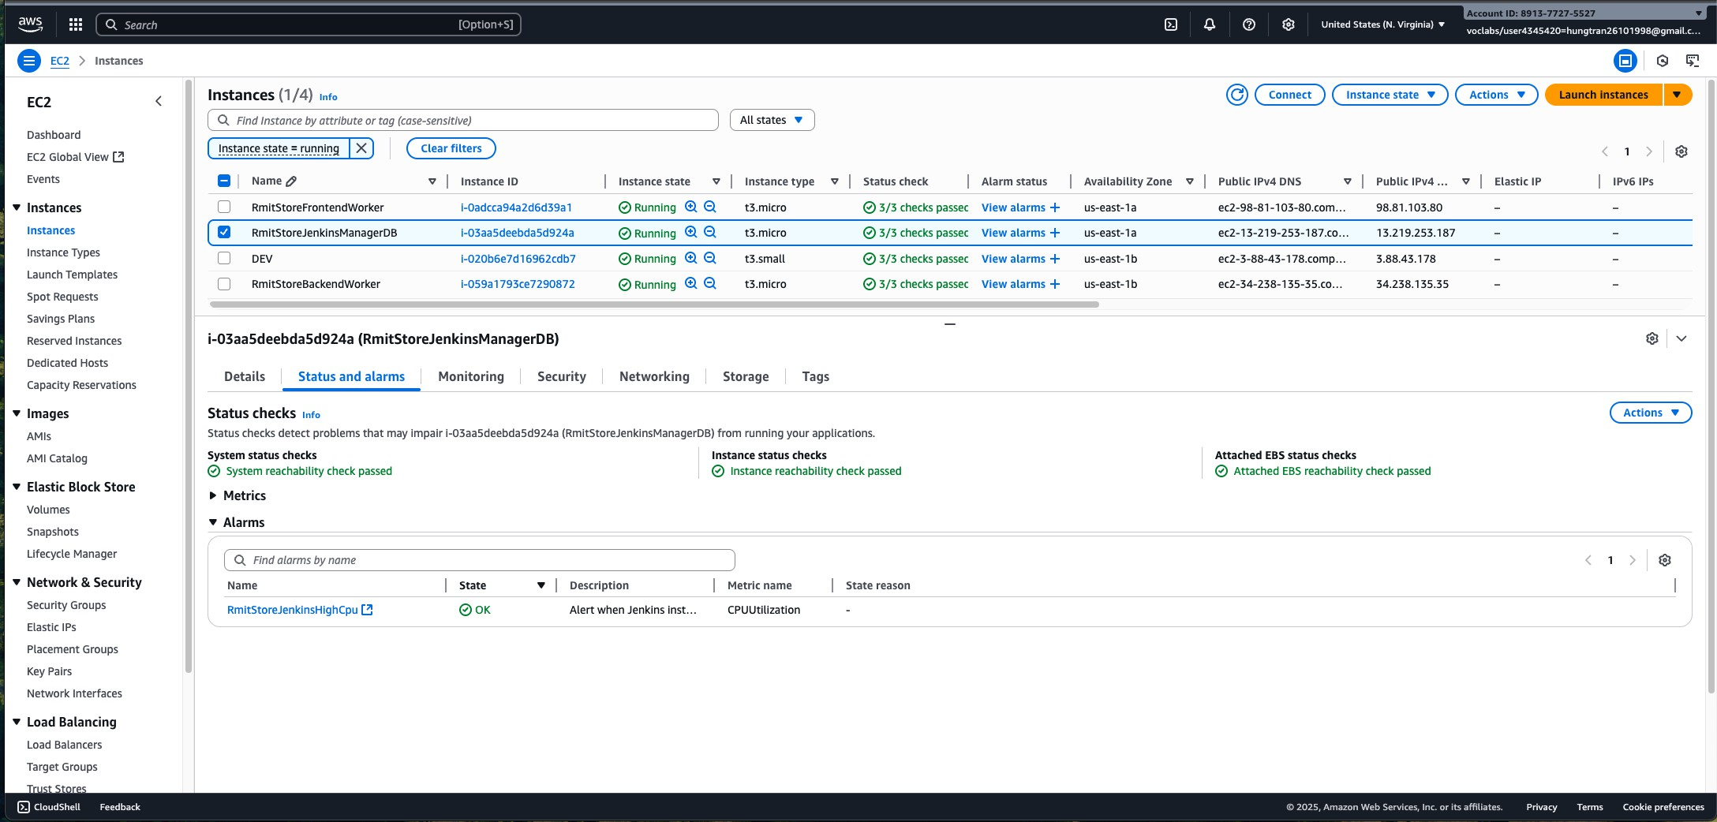
Figure 1 EC2 Instances Setup Results
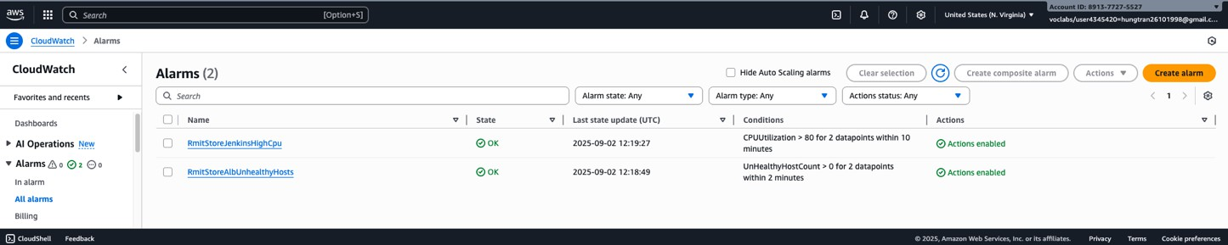

Figure 2 CloudWatch Setup Result

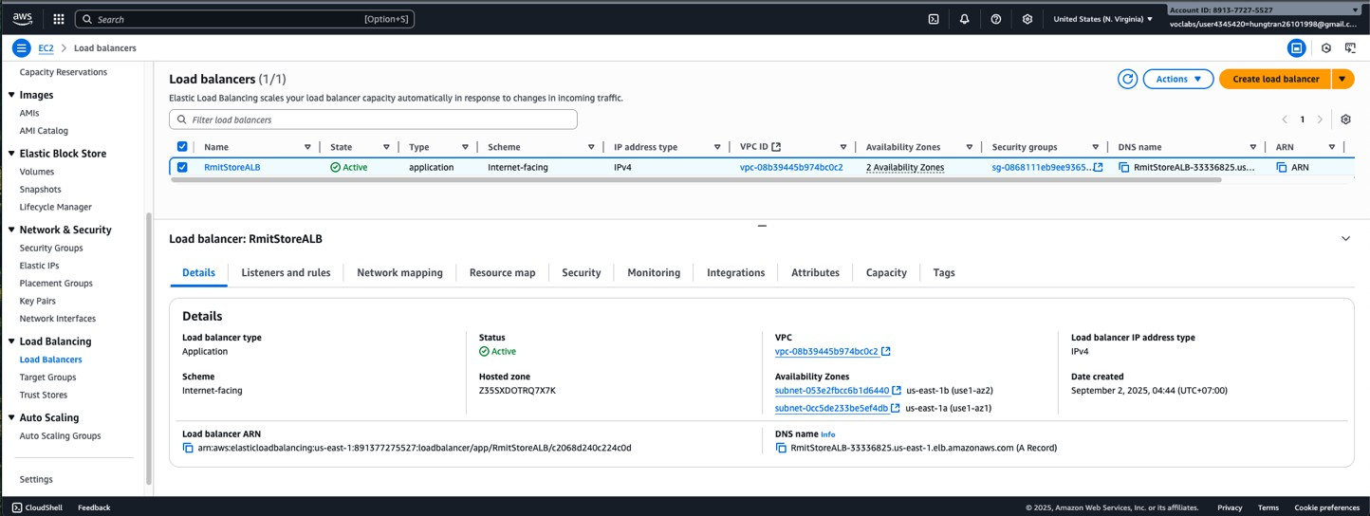
Figure 3 Application Load Balancer Setup Result
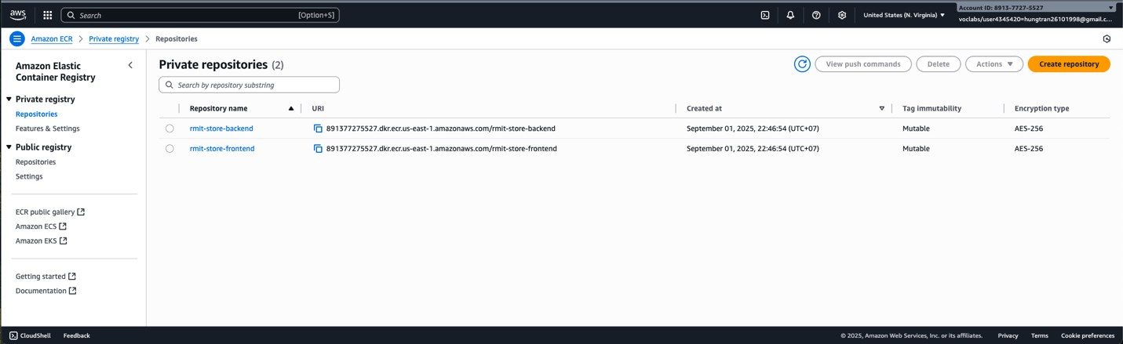
Figure 4 ERC setup result

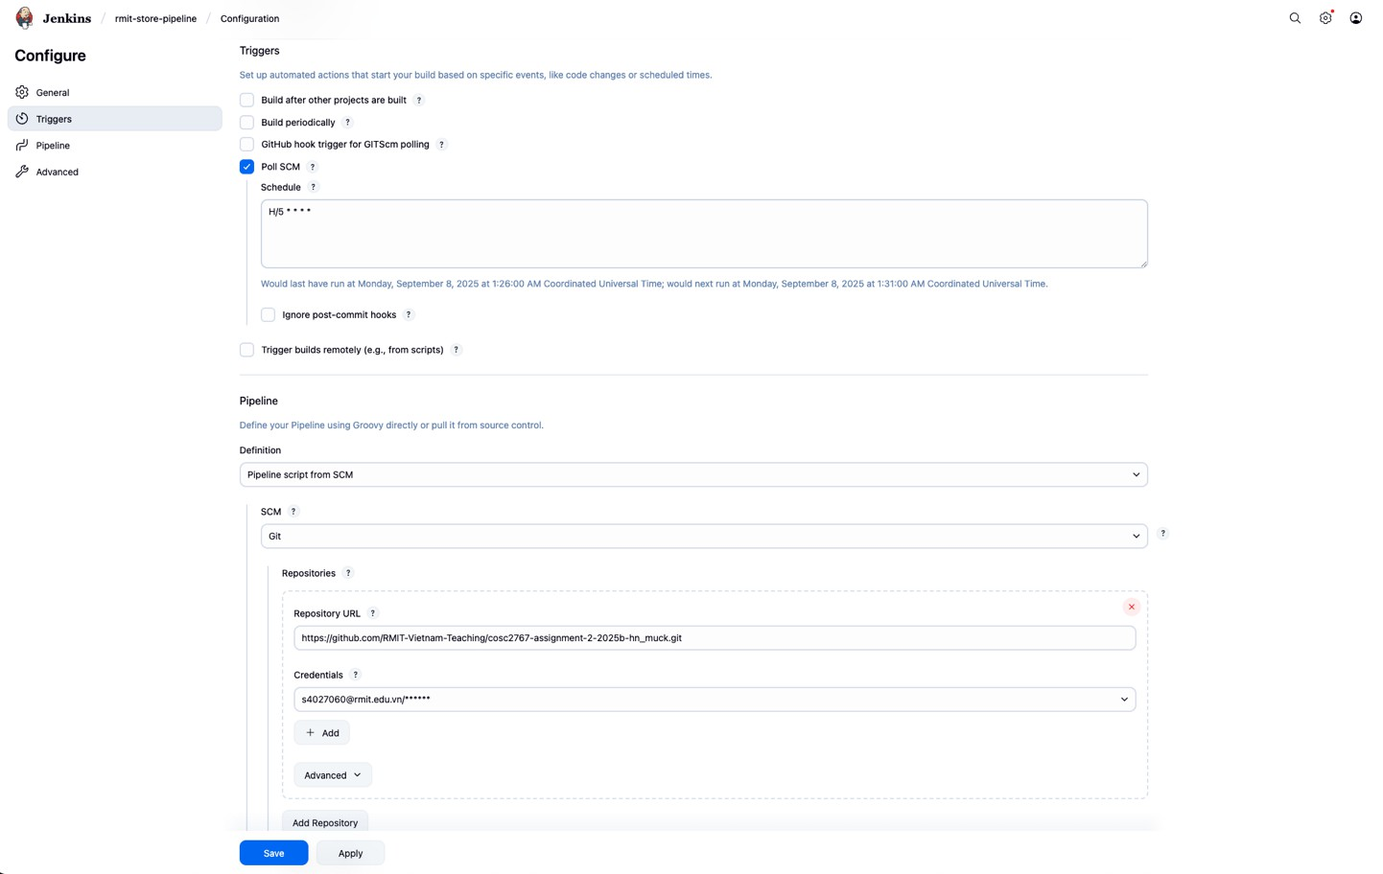
Figure 5 Jenkin Pipeline Trigger Rules
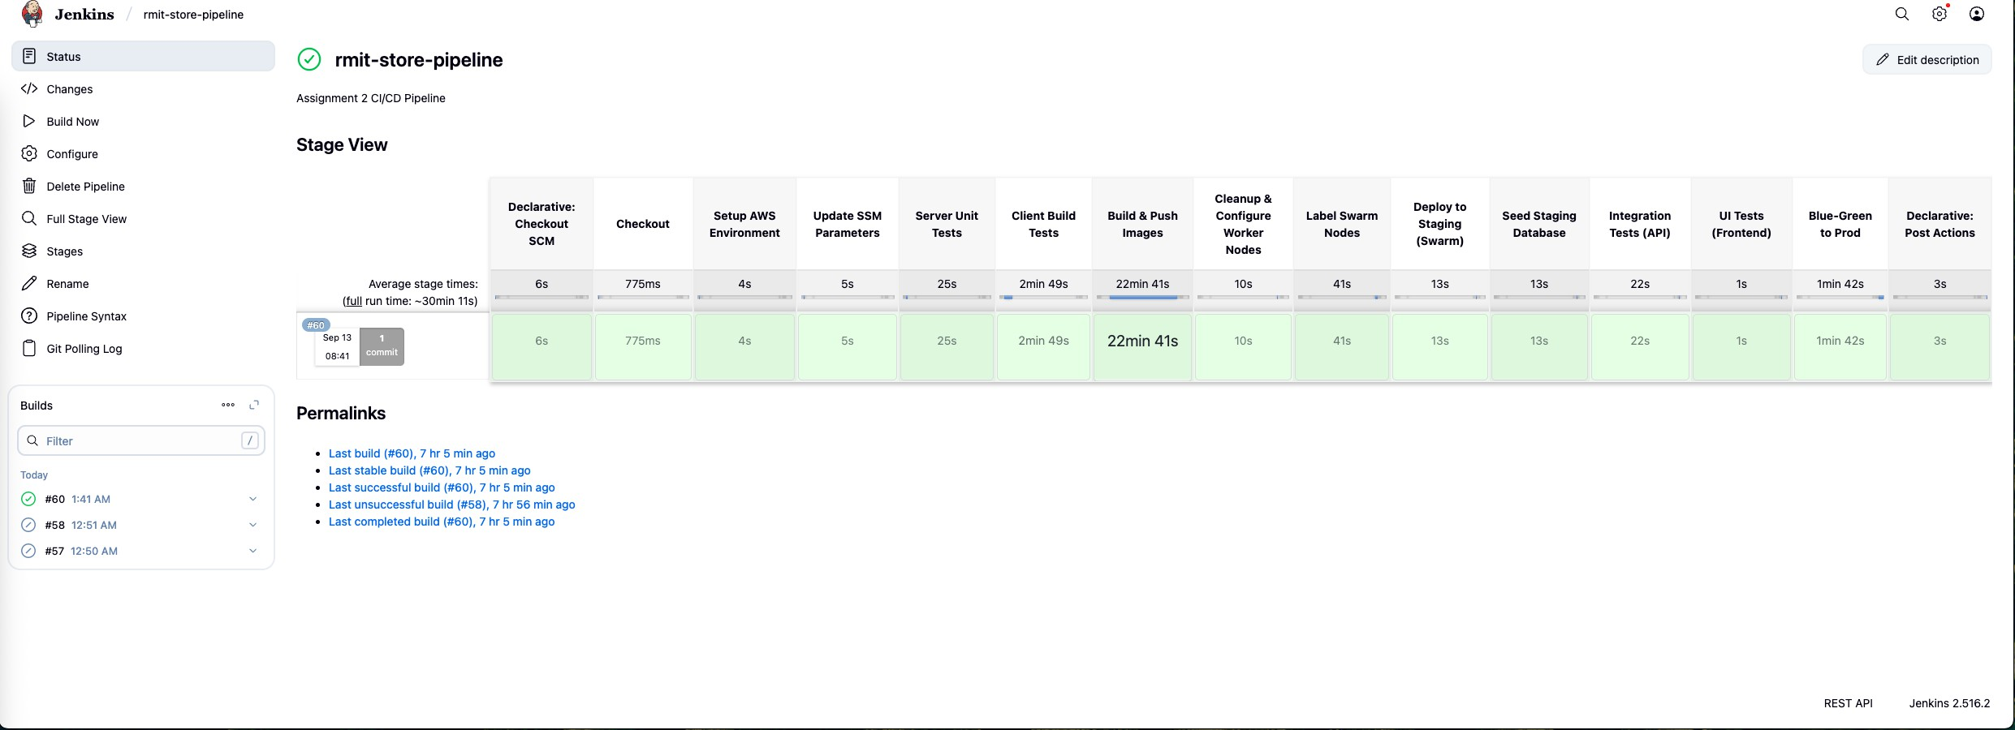
Figure 6 Jenkin CI/CD Pipeline

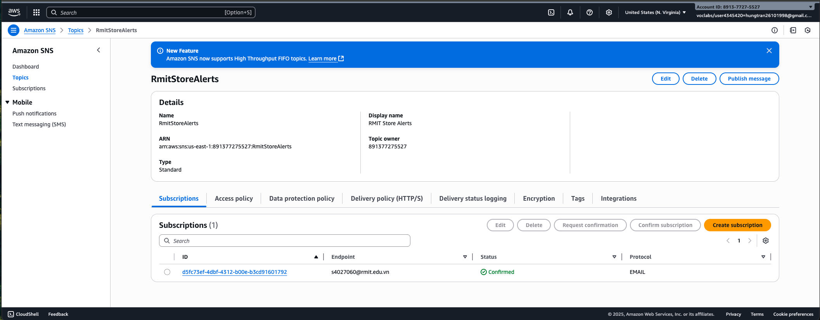
Figure 7 SNS Notification setup result

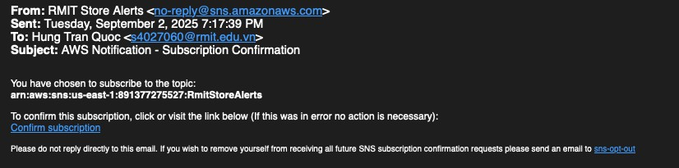
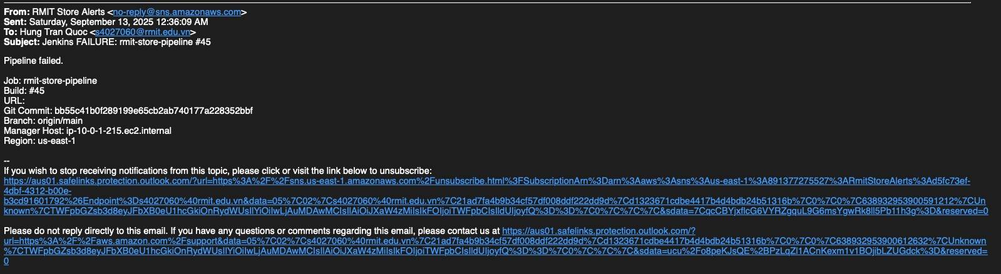

Figure 8 RMIT Store Alert

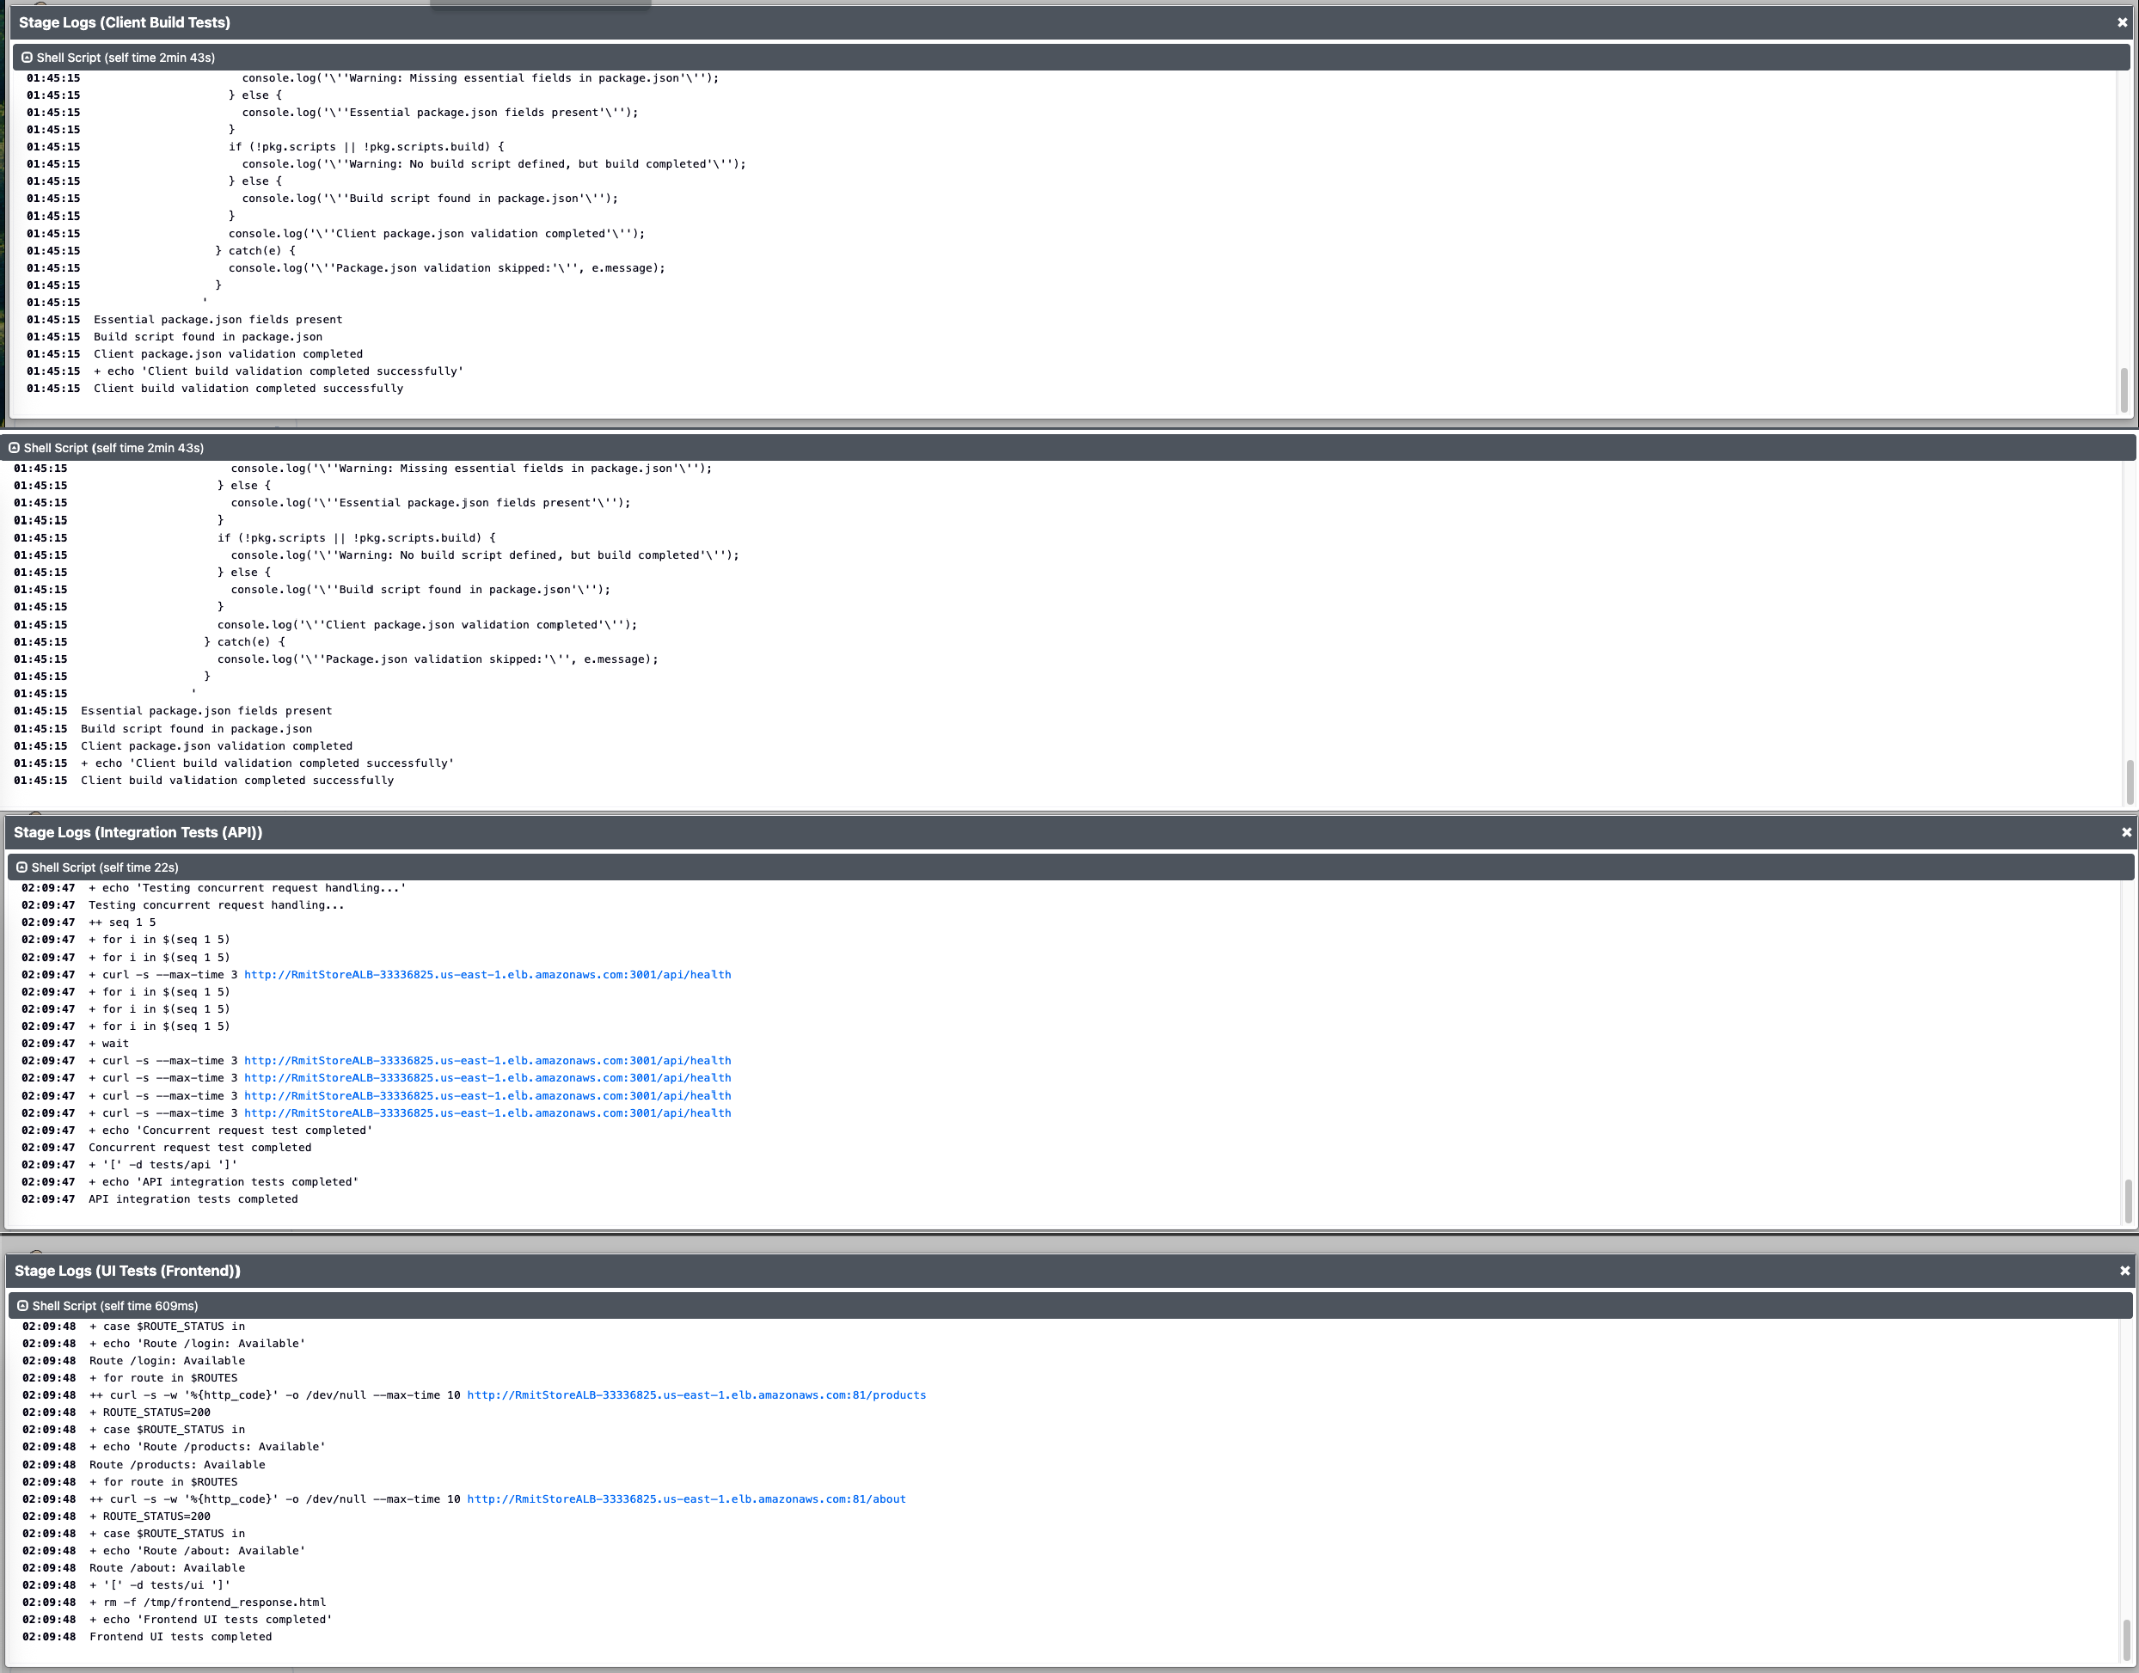

Figure 9: Sample output for testing framework

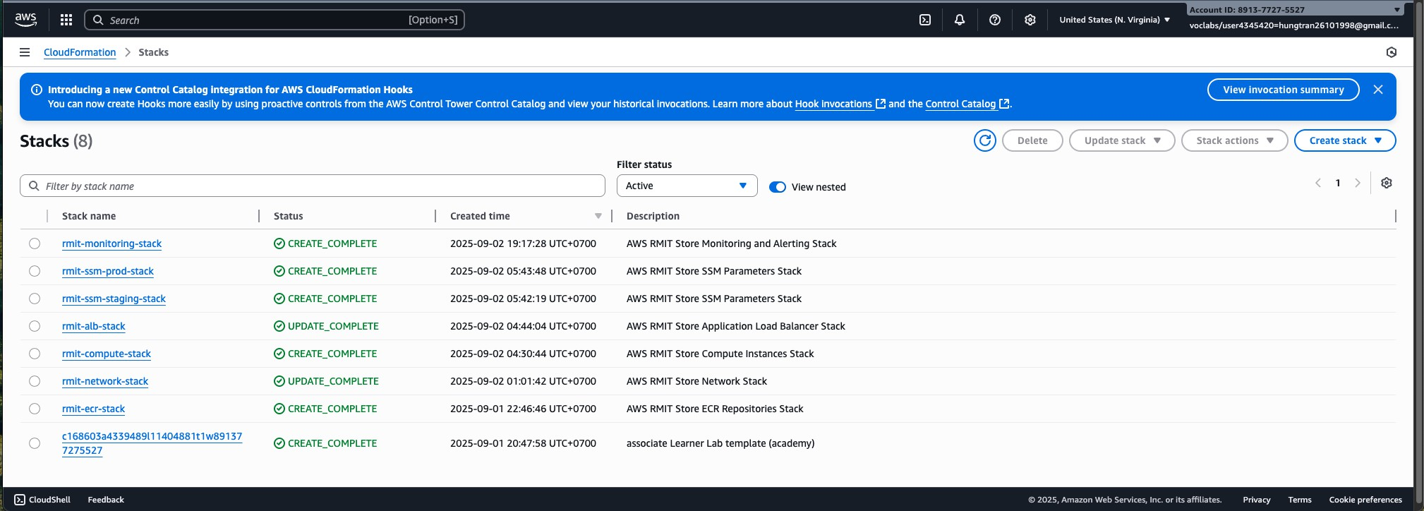

Figure 9 Cloud Formation setup
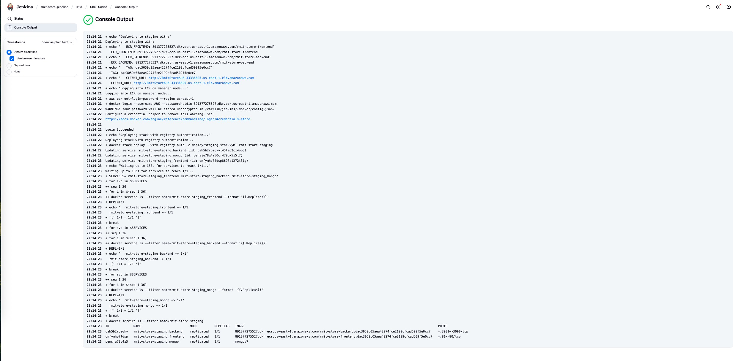
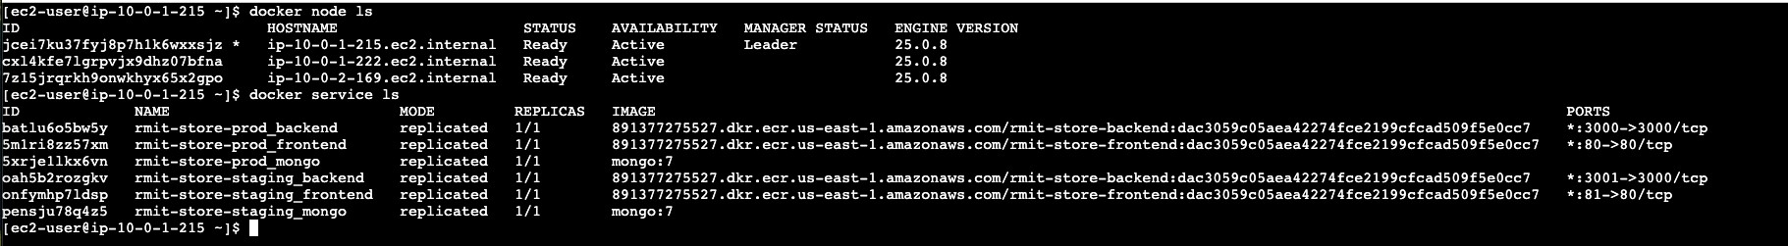

Figure 11 Docker Swarm Setup Result

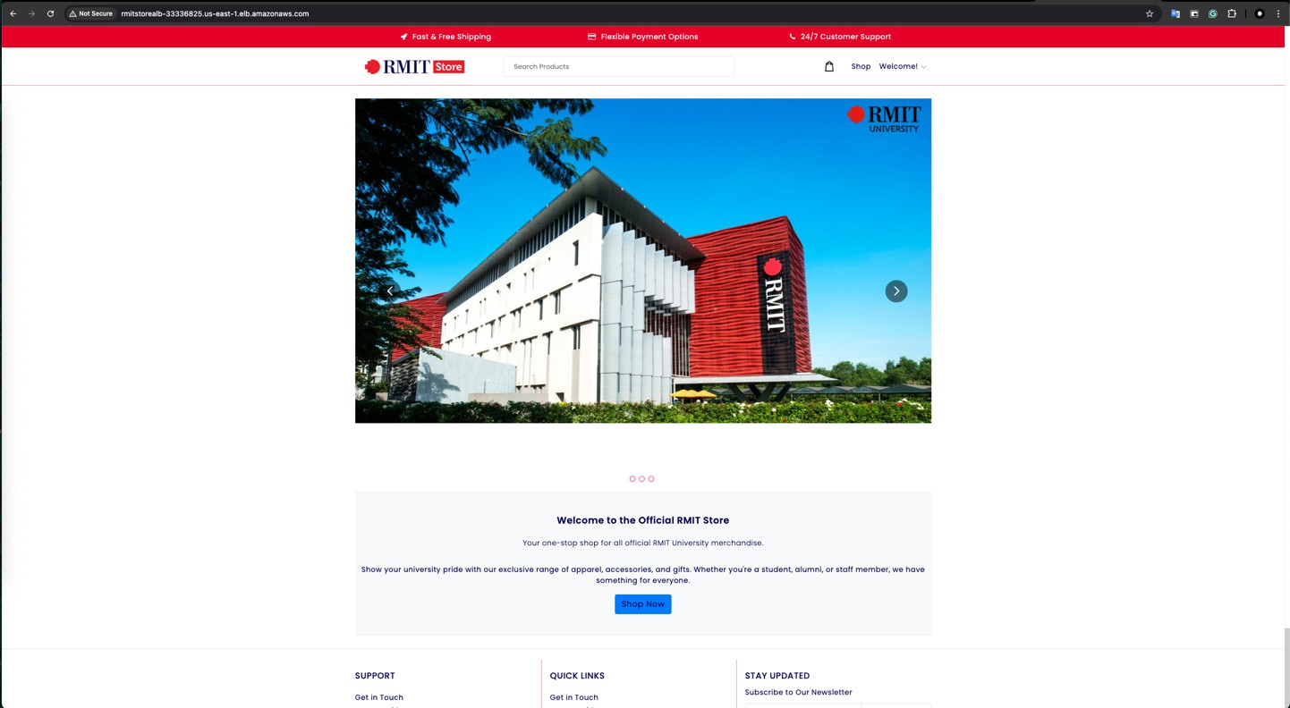
Figure 12 Standard Version - Port81
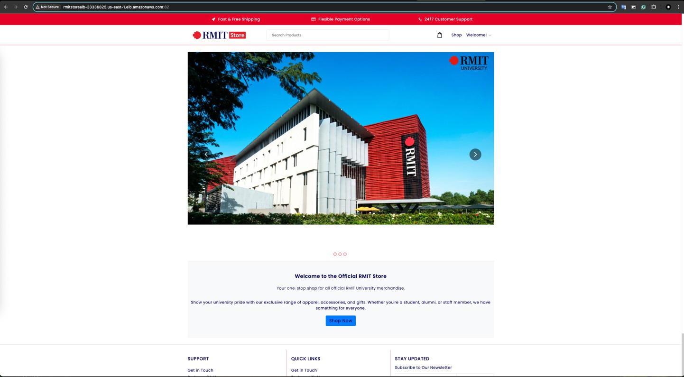
Figure 13 Preview Version - Port 82

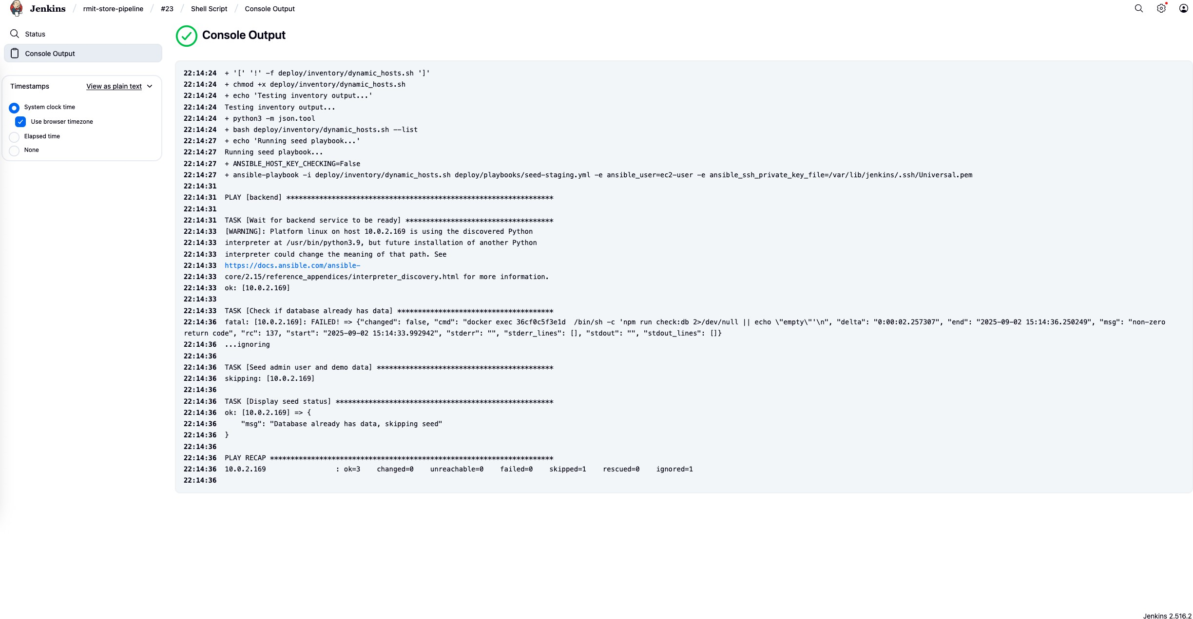

Figure 14 Ansible Output
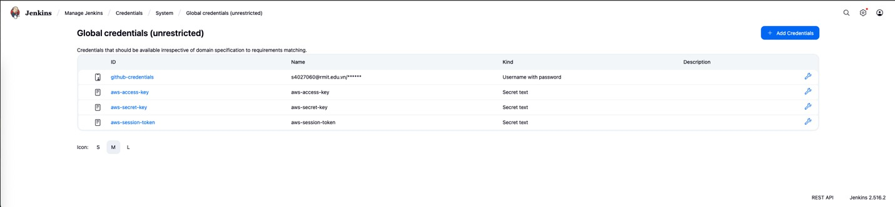
Figure 15 Jenkin Credentials

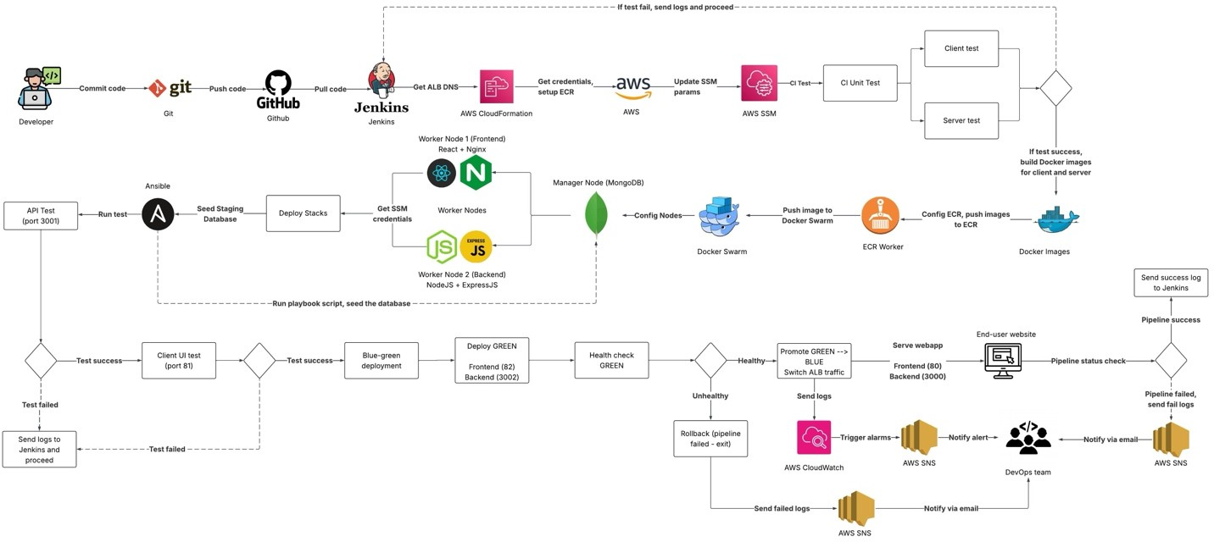
Figure 16 Application Flow

References

- Amazon Web Services, "Application Load Balancer | Elastic Load Balancing | Amazon Web Services," 2025. [Online]. Available: https://aws.amazon.com/elasticloadbalancing/application-balancer/. [Accessed 01 Sep 2025].
- Amazon Web Services, "What is AWS CloudFormation?," 2025. [Online]. Available: https://docs.aws.amazon.com/AWSCloudFormation/latest/UserGuide/Welcome.html. [Accessed 02 Sep 2025].
- Amazon Web Service, "What is Amazon Elastic Container Registry? - Amazon ECR," 2025. [Online]. Available: https://docs.aws.amazon.com/AmazonECR/latest/userguide/what-is-ecr.html. [Accessed 02 Sep 2025].
- Amazon Web Services, "Send Push Notifications - Amazon SNS - AWS," 2025. [Online]. Available: https://aws.amazon.com/sns/. [Accessed 02 Sep 2025].
- Amazon Web Services, "Secure and resizable compute capacity for virtually any workload," Amazon Web Services, 2025. [Online]. Available: https://aws.amazon.com/ec2/?trk=edca3a7f-0269-4987-8b3f-
4bb531aa8cc6&sc_channel=ps&ef_id=CjwKCAjwiY_GBhBEEiwAFaghvrLEtZOy79atLSB MWmEatO6ayZvR6RKn8OdqJFfRbiaxq4RZNnNc7BoCvZAQAvD_BwE:G:s&s_kwcid=AL
!4422!3!770487102128!p!!g!!ec2%20virtual%20machine!229187660. [Accessed 02 Sep 2025].
- Amazon Web Services, "Amazon Monitoring and Observability-Amazon CloudWatch - AWS," Amazon Web Services, 2025. [Online]. Available: https://aws.amazon.com/cloudwatch/. [Accessed 02 Sep 2025].
- CD Foundation The Linux Foundation, "Jenkin," 2025. [Online]. Available: https://www.jenkins.io/. [Accessed 02 Sep 2025].
- Red Hat, "Ansible Collaborative - How Ansible Works," Red Hat, 2025. [Online]. Available: https://www.redhat.com/en/ansible-collaborative/how-ansible-works. [Accessed 02 Sep 2025].
- Docker Inc., "Swarm mode," 2025. [Online]. Available: https://docs.docker.com/engine/swarm/. [Accessed 02 Sep 2025].
- Docker Inc, "What is a Container? | Docker," 2025. [Online]. Available: https://www.docker.com/resources/what-container/. [Accessed 02 Sep 2025].

- RMIT Vietnam, "RMIT-Vietnam-Teaching/cosc2767-assignment-2-2025b-hn_muck," 2025. [Online]. Available: https://github.com/RMIT-Vietnam-Teaching/cosc2767-assignment-2-2025b-hn_muck. [Accessed 15 Sep 2025].

